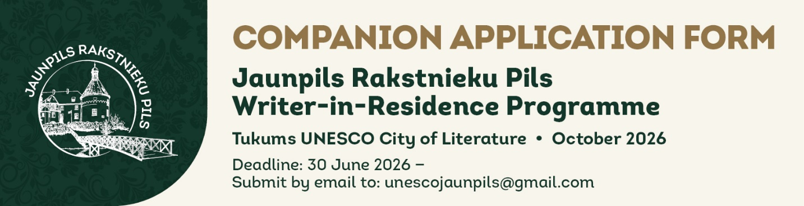

HOW TO COMPLETE THIS FORM Please type your answers directly into this document (click in the shaded fields or after the question text). Save the completed form and email it to unescojaunpils@gmail.com together with any required attachments. The form must be submitted in English. Font: Arial Narrow (or Arial if unavailable). Answers should be concise and honest — there is no advantage to writing the maximum word count if fewer words serve the purpose.

I. MAIN RESIDENT

First Name |  | Last Name

II. COMPANION, PERSONAL DETAILS

First Name |  | Last Name

Date of Birth |  | Nationality

Gender / Preferred pronouns (optional — e.g. she/her, he/him, they/them, or free text)

Home Address (street, city, country, postal code)

Phone (with international dialling code) |  | E-mail address

Website and/or social media profiles (e.g. personal website, Facebook, Instagram, LinkedIn — optional)

Any other information you consider relevant (e.g. medical conditions or access needs the organisers should be aware of — optional)

RESIDENCY PERIOD (must match the dates selected by the main resident)
Please select one option:
☐ Four-week residency: 1–28 October 2026 (including arrival and departure days)
☐ Two-week residency — first half: 1–15 October 2026 (including arrival and departure days)
☐ Two-week residency — second half: 17–30 October 2026 (including arrival and departure days)

III. PROFESSIONAL EXPERIENCE

Overview of your literary work and achievements (max 500 words)

IV. DECLARATION AND CONSENTS

Please read each statement carefully and tick the box to confirm your agreement. All three declarations are required for your application to be considered.
☐ I confirm that all information provided in this application form is accurate and complete to the best of my knowledge.
☐ I consent to the Tukums City of Literature processing the personal data I have provided in this form and its attachments for the purposes of administering the Jaunpils Writer-in-Residence Programme — including applicant selection and programme implementation — in accordance with Article 6(1)(a) of Regulation (EU) 2016/679 (GDPR). I understand that I may withdraw this consent at any time by contacting unescojaunpils@gmail.com.
☐ If selected, I agree to the publication of my name on the Tukums City of Literature website and social media profiles (Facebook, Instagram) in connection with the announcement of the residency.
Full Name |  | Date

As this is a Word document submitted by email, a typed name in the Name field above is accepted in place of a handwritten signature.

Submit your completed application by 30 June 2026 to unescojaunpils@gmail.com. Selected residents will be notified by email in early August 2026.

Tukums UNESCO City of Literature • tukums.lv • unescojaunpils@gmail.com

